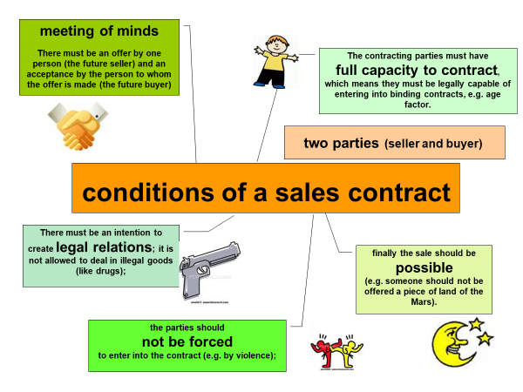
English | German
conditions of a sales contract | Voraussetzungen eines Kaufvertrags
meeting of minds | Übereinstimmende Willenserklärung
(legal) capacity to contract | Geschäftsfähigkeit
legal | gesetzlich
possible | möglich
not to be forced | ohne Zwang
voluntariness | Freiwilligkeit
to found a company | ein Unternehmen gründen
workshop | Werkstatt
valid contract | gültiger Vertrag
wholesaler | Großhändler
trims | Bordüren
embroidered | bestickt
disguised | getarnt

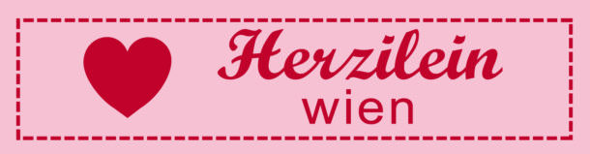
Case Study “Herzilein”: (book p.81)

Several years ago, Sonja Völker founded a company named “Herzilein GmbH”. She sells fashion for children. As her business is very successful, she already has three fashion shops in Vienna, where she sells her creations. She also runs a web shop. The clothes are manufactured in a separate workshop.

Decide whether a valid sales contract has been concluded in the following cases:

Case | Valid contract yes/no? | Reasons
- Lili, six years old, walks into a “Herzilein” shop and buys a summer dress for € 70.
- A wholesaler says to Ms. Völker: “If you don’t buy these trims from me, I will punch you in the face.”
- Julia, 33 years old, buys an embroidered sailor-style pullover for her son.
- Ms. Völker’s boyfriend says to her: “I love you so much, I will buy all the stars in the Milky Way for you.”
- A Young man calls Ms. Völker and offers her designer drugs for children, which she could hand out in her shop disguised as sweets.

